Supplementary Material
Atractylodes Macrocephala Koidz. Derived Exosome-like Nanovesicles Promoted Osteogenic Differentiation of hBMSCs Via Regulating SOD2 and Postponed Osteoporosis of Ovariectomized Rats

Ziquan Zhao ^{1, †}, Zhina Peng ^{2, †}, Weixiong Guo ¹, Xuyang Wu ¹, Zhuolan Zhong ¹, Tianyi Hu ², Xinqia Huang ¹, Mingzhu Deng ¹, Weiqiang Zhan ¹, Jiaqi Chu^{2,3, *}

¹Orthopaedic Center, Affiliated Hospital of Guangdong Medical University, 524001 Zhanjiang, Guangdong, China
²Department of Obstetrics and Gynecology, Affiliated Hospital of Guangdong Medical University, 524001 Zhanjiang, Guangdong, China
³Stem Cell Research and Cellular Therapy Center, Affiliated Hospital of Guangdong Medical University, 524001 Zhanjiang, Guangdong, China
*Correspondence: chujiaqi@gdmu.edu.cn (Jiaqi Chu)

†These authors contributed equally.

ORCID:
Ziquan Zhao: 0009-0008-7156-1645
Zhina Peng: 0009-0002-6149-5820
Weixiong Guo: 0009-0007-9238-6332
Xuyang Wu: 0009-0005-6929-3387
Zhuolan Zhong: 0009-0006-6995-9828
Tianyi Hu: 0009-0003-5761-6535
Xinqia Huang: 0000-0002-3046-897X
Mingzhu Deng: 0000-0003-0258-7354
Weiqiang Zhan: 0000-0003-3308-299X
Jiaqi Chu: 0000-0002-2306-1805

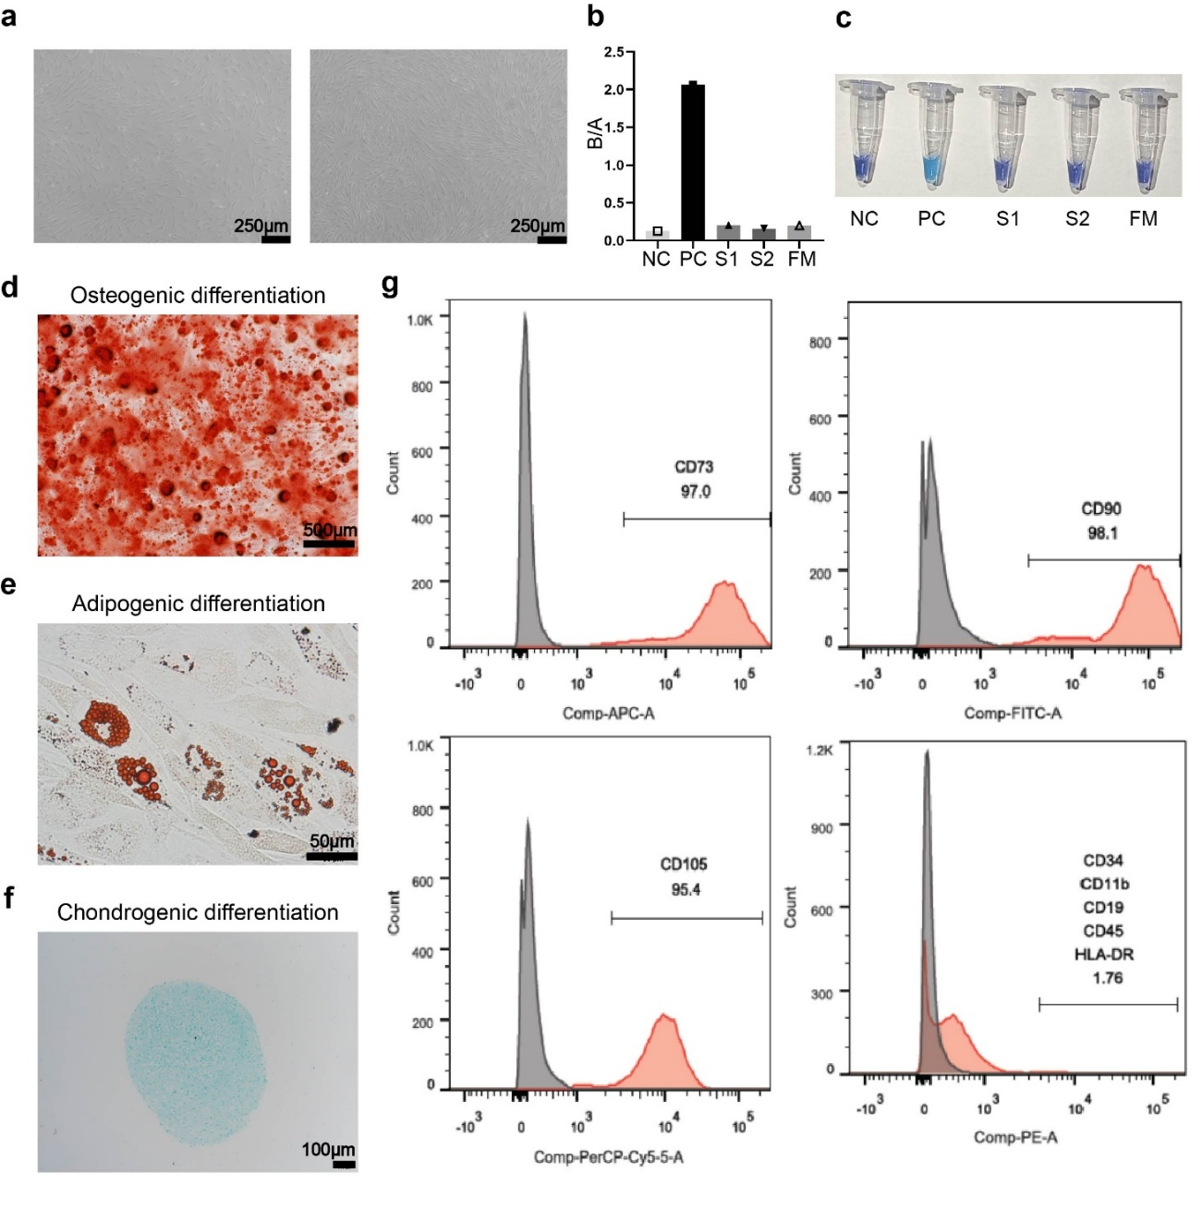
Supplementary Fig. 1. Isolation and characterization of human bone marrow mesenchymal stem cells (hBMSCs). (a) Cell morphology of hBMSCs at day 1 of Passage 5 and day 3 of Passage 5. (Scale bar = 250 μm) (b-c) The detection of mycoplasma during the culture of hBMSCs. NC, PBS for the negative control; PC, positive control solution from the kit; S1, supernatant sample of hBMSCs cell culture; S2, supernatant sample of hBMSCs from another patient; FM, fresh medium for cell culture. (d-f) Assessment of hBMSCs’ trilineage differentiation abilities: Alizarin red staining for osteogenic differentiation (d), Oil red O staining for adipogenic differentiation (e), and Alcian blue staining for chondrogenic differentiation (f). (g) Flow cytometry analysis of cell surface markers. The hBMSCs showed positive expressions of CD73, CD90, CD105, and negative expressions of CD19, CD11b, CD34, CD45, and HLA-DR. CD, cluster of differentiation; HLA-DR, Human Leukocyte Antigen - DR isotype. The results exported by Graphpad Prism 9.5.0 and Flow Jo X (Version 10.0.7) were assembled using Adobe Illustrator 2023 (Version 27.0.1).

Supplementary Table 1. Antibodies’ information.
 | Antibody | Cat.No | Ratio | Manufacturer | Use
Primary Antibody | ALP | R23427 | 1:1000 | ZEN Bio | WB
Primary Antibody | RUNX2 | AF5186 | 1:1000 | Affinity | WB
Primary Antibody | OPN | sc-21742 | 1:500 | Santa Cruz | WB
Primary Antibody | β-actin | K200058M | 1:5000 | Solarbio | WB
Primary Antibody | SOD2 | 306028 | 1:1000 | ZEN Bio | WB
Primary Antibody | RUNX2 | 860139 | 1:100 | ZEN Bio | IHC
Primary Antibody | OCN | 514636 | 1:100 | ZEN Bio | IHC
 | α-Tubulin | sc-32293 | 1:400 | Santa Cruz | IF
Secondary Antibody | Alexa Fluor™ 488 Goat anti-Mouse IgG (H+L) | A11029 | 1:400 | Invitrogen | IF
Secondary Antibody | IRDye®680RD Goat anti-Mouse IgG (H + L) | 926-68070 | 1:20000 | LI-COR | WB
Secondary Antibody | IRDye®680RD Goat anti-Rabbit IgG (H + L) | 926-68071 | 1:20000 | LI-COR | WB
Secondary Antibody | IRDye®800CW Goat anti-Mouse IgG (H + L) | 926-32210 | 1:20000 | LI-COR | WB
Secondary Antibody | IRDye®800CW Goat anti-Rabbit IgG (H + L) | 926-32211 | 1:20000 | LI-COR | WB
WB: Western Blot; IHC: Immunohistochemistry; IF: Immunofluorescence.

